Why is this guy naked?
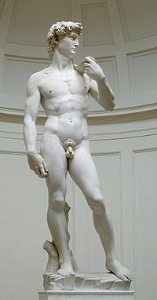

Take A.P. Art History
And find out……

