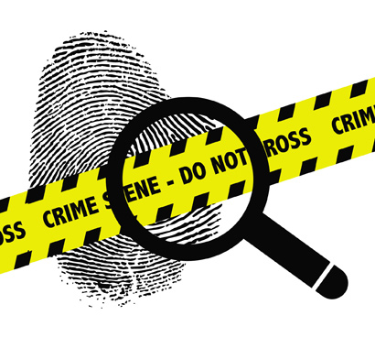
Forensic Science

Do you love CSI, NCIS, Criminal Minds, and all the other great crime solving shows?
If you do, then we have the class for you. Grangers very own Forensic Science Class, Come learn where this all begins.
We will use scientific techniques and technology to analyze physical evidence found at crime scenes. This includes Crime scene investigation, Finger printing, blood typing, vehicle crash reconstruction and much much more.

½ year Science elective credit
Open to all 10th, 11th and 12th grade students
Taught by Mr. Price

