***What is Psychology?***

Psychology is the study of the human behavior and mental processes. How we think and how we act!

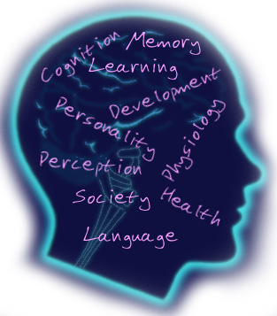

Every Major in college will require Psychology so take it now!

**What do I learn about?**

**Psychology**

History of Psychology (Scientific Method, Perspectives, Careers, DSM ) Neuroscience (Neurons, Brain Parts & Function, Nervous Systems, L/R Brain), Consciousness (Sleep Stages, Dreams, Hypnosis, ESP, De Ja Vu, Subliminal Messages, NDE, DID, Freud, Personality (Type A/B, Somatotypes, Birth Order, Id, Ego, Super Ego, Psychosexual Stages, Defense Mechanisms) , Psychological Disorders (Anxiety, OCD, Panic, Phobias, PTSD, Depression, Suicide, Amnesia, Fugue, Conversion, Hypochondrias, Schizophrenia, Anorexia, Bulimia, and Social Psychology (Discrimination, Prejudice Stereotyping, Friendship, Love Marriage, Body Language & Image).

Psychology is an excellent class to take to answer all of those questions you wonder about like… Why do we do what we do? Why do we feel this way or why did I just say that? What happens when I’m asleep? What are Psychological disorders?

This course is loaded with FUN and **E**xcitement All Semester! Sign up today!

**AP Psychology**

History of Psychology, Research

Methods, Thinking, Language,

Intelligence, Memory, Learning,

Development, Consciousness,

Abnormal, Therapy, Emotion,

Sensation/Perception, Personality,

Motivation, Stress & Health, (Brain)

Neuroscience, & Social Psychology.

This college leveled class goes into

extensive detail in each unit. You

will be excited to attend class

and will never wonder why am I

learning this because it applies to

your real life. Be prepared to

***Expect the Unexpected*** every day

in All Psychology classes.

**Sports Psychology**

Focus, Confidence, Motivation,

Visualization, Mental Toughness,

Getting Psyched-Up, How to avoid

choking, Performance pressure and

much, much more! Are you an

Athlete? Need a competitive edge?

Do you want to increase your

leadership skills? Then **Sports**

**Psychology** is the class for you!

***j0286000***

***Psychology***

***AP Psychology***

***Sports Psychology***

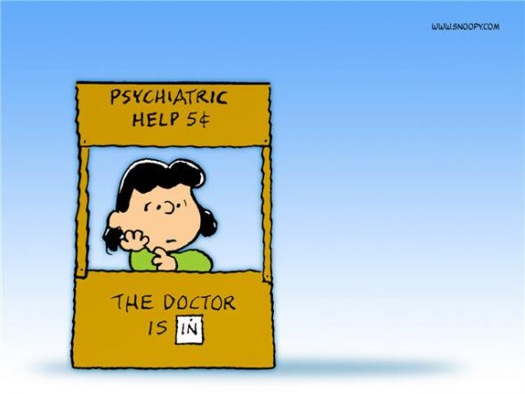

***Expect the Unexpected!***

***Mrs. Gaskins***

***Class Activities***

**Psychology**

In this class, you will participate in experiments, keep a dream diary, dissect a brain, create a personality mask, go on a field trip and invent a Superhero! In All Psychology classes you will experience real world applications that will leave you excited to learn more each day!

**AP Psychology**

You will participate in activities, and experiments each day such as; role plays, experiments, relay races, field trips, illusions, hands on activities, games just to name a few. The adventure never ends!

**Sports Psychology**

You will learn techniques to help you mentally prepare for all performance situations. Competitive athletes, performers or students who want to strengthen their leadership skills and competitive edge will love this class. You will participate in numerous hands on activities and much more!

***Who can take the class?***

**Psychology**

Psychology can be taken by all 10th,

11th, & 12th graders. Everyone is

welcome! You will see this class

apply to your life! (Semester class)

**AP Psychology**

AP Psychology is open to all 11th &

12th graders (it is NOT required to

take Psychology before enrolling

in AP Psychology! AP Psychology is

a college level class and you can

earn (4 Semester college credits!)

This class WILL prepare you to

become a college ready student!

You will love this class!

(Full Year Class)

***Sports Psychology***

All 10th, 11th, & 12th graders are welcome to take Sports Psychology. Be a part of the Granger Team! You will be very interactive and hands on with relevant discussion topics, activities and experiments. Sports Psychology will be a class that will assist you in all aspects of your life and help you to achieve your potential. (Semester Class)