**(Junior Class of 2026)**

SOPHOMORES

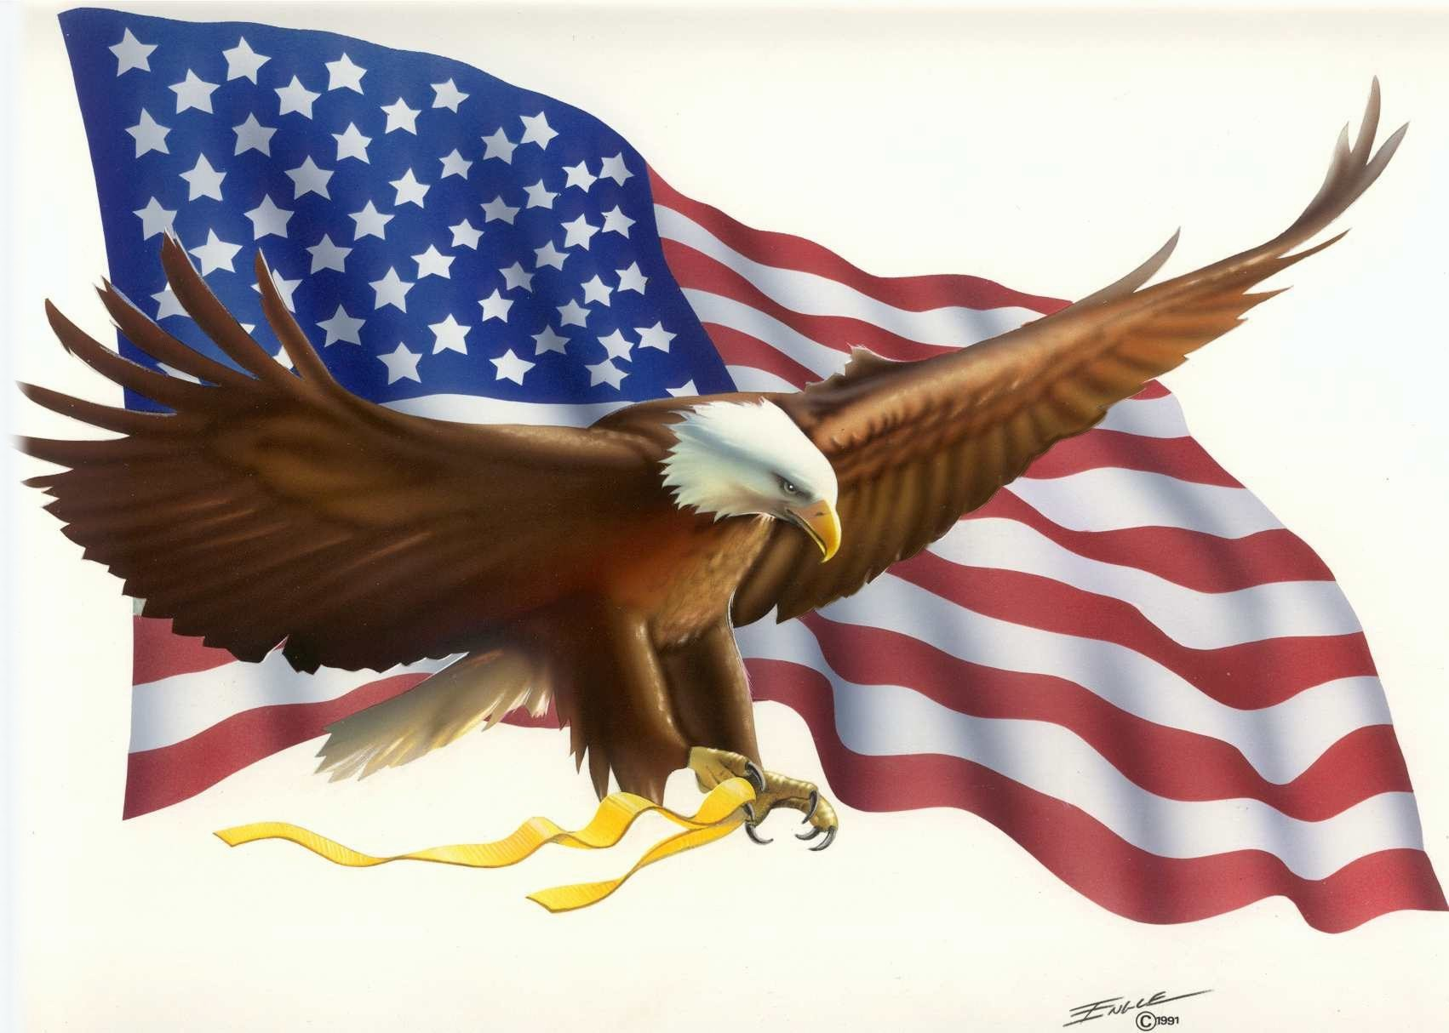

**Would you like to get college credit while taking your required American History class?**

CHOOSE

History 1700

AMERICAN CIVILIZATION

Seniors 2025 can take it too!

See Mr. Fuller (Room H109) for more information!