***AP Psychology***

***CE PSY 1010***

***Psychology***

***Sport Psychology***

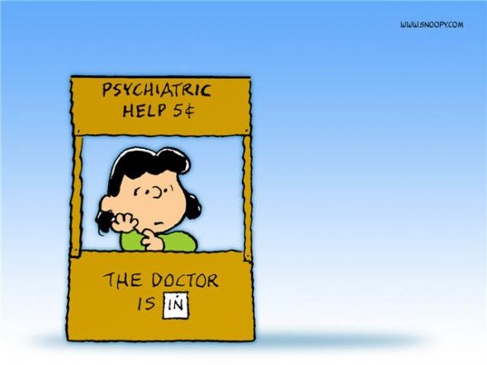

***Expect the Unexpected!***

***Mrs. Gaskins***

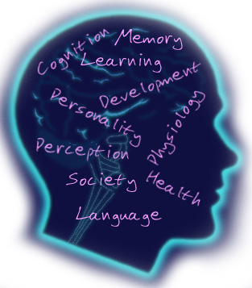 ***j0286000***

***What is Psychology?***

Psychology is the study of the human behavior and mental processes. How we think and how we act! Every Major in college will require Psychology so take it now!

**What do I learn about?**

**Psychology**

History of Psychology (Scientific Method, Perspectives, Careers, DSM ) Neuroscience (Neurons, Brain Parts & Function, Nervous Systems, L/R Brain), Consciousness (Sleep Stages, Dreams, Hypnosis, ESP, De Ja Vu, Subliminal Messages, NDE, DID, Freud, Personality (Type A/B, Somatotypes, Birth Order, Id, Ego, Super Ego, Psychosexual Stages, Defense Mechanisms) , Psychological Disorders (Anxiety, OCD, Panic, Phobias, PTSD, Depression, Suicide, Amnesia, Fugue, Conversion, Hypochondria’s, Schizophrenia, Anorexia, Bulimia, and Social Psychology (Discrimination, Prejudice Stereotyping, Friendship, Love Marriage, Body Language & Image).

Psychology is an excellent class to take to answer all of those questions you wonder about like… Why do we do what we do? Why do we feel this way or why did I just say that? What happens when I’m asleep? What are Psychological disorders?

This course is loaded with FUN and Excitement All Semester! Sign up today!

**AP Psychology & CE PSY 1010**

History of Psychology, Research

Methods, Thinking, Language,

Intelligence, Memory, Learning,

Development, Consciousness,

Abnormal, Therapy, Emotion,

Sensation/Perception, Personality,

Motivation, Stress & Health, (Brain)

Neuroscience, & Social Psychology.

This college leveled class goes into

extensive detail in each unit. You

will be excited to attend class

and will never wonder why I am

learning this because it applies to

your real life. Be prepared to

***Expect the Unexpected*** every day

in All Psychology classes.

**Sport & Performance Psychology**

Getting Physically & Mentally Tough,

Relaxation, Leadership, Sportsmanship,

Intensity, Commitment, Emotions.

Focus, Confidence, Motivation,

Visualization, Mental Toughness,

Getting Psyched-Up, how to avoid

choking, Performance pressure and

much, much more! Are you an

Athlete? Debate? Band/Choir?

Drama? SBO? Need a competitive

edge? Do you want to increase your

leadership skills? Then **Sport**

**Psychology** is the class for you!

***Class Activities***

**AP Psychology**

You will participate in activities, and experiments each day such as; role plays, experiments, relay races, field trips, illusions, hands on activities, games just to name a few. The adventure never ends!

**CE Psychology 1010**

In addition to some of the AP Psychology activities and content, you will participate in hands on activities, discussions, relevant knowledge for any career, interest and real-world experiences in life.

**Psychology**

In this class, you will participate in numerous class activities and experiments, keep a dream diary, dissect a brain, create a personality mask, go on a field trip and create a Superhero, make inkblots! In All Psychology classes you will experience real world applications that will leave you excited to learn more each day!

**Sport & Performance Psychology**

You will learn techniques to help you mentally prepare for all performance situations. Competitive athletes, performers or students who want to strengthen their leadership skills and competitive edge will love this class. You will participate in numerous hands on activities and much more!

***Who can take the class?***

**AP Psychology**

AP Psychology is open to all 11th &

12th graders (it is NOT required to

take Psychology before enrolling

in AP Psychology! AP Psychology is

a college level class and you can

earn (4 Semester college credits!) when you pass the national AP test.

This class WILL prepare you to

become a college ready student!

You will love AP Psychology!

(Full Year Class)

**CE Psychology 1010**

CE PSY 1010 is open to all 11th & 12th grade students who want the challenge of a college course, earn college credit & save a lot of money in tuition. This college course is taught at Granger High School through Salt Lake Community College. Students will earn college and high school credit. Psychology 1010 is a required course in college that you could fulfill while in high school (it is NOT required to take Psychology before enrolling in CE Psych 1010! (Semester class)

**Psychology**

Psychology can be taken by all 10th,

11th, & 12th graders. Everyone is

welcome! No prerequisites are required to sign up. You will see this class apply to every aspect of your life! (Semester class)

***Sport & Performance Psychology***

All 10th, 11th, & 12th graders are welcome to take Sport Psychology. Be a part of the Granger Team! You will be very interactive throughout this class with hands on and relevant discussion topics, activities and experiments. Sport Psychology is a class that will assist you in all aspects of your life and help you to achieve your potential. No prerequisites are required to sign up. (Semester Class)