[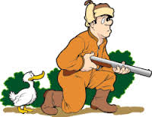](http://www.google.com/imgres?imgurl=http://www.picgifs.com/job-graphics/job-graphics/hunters/jagers09.gif&imgrefurl=http://www.picgifs.com/job-graphics/hunters/&h=193&w=250&tbnid=YT2XU3xdVMDf8M:&zoom=1&docid=vmWKI3RddWM0eM&ei=-IXCVMulKcPjoATko4DICw&tbm=isch&ved=0CEEQMyg5MDk4yAE)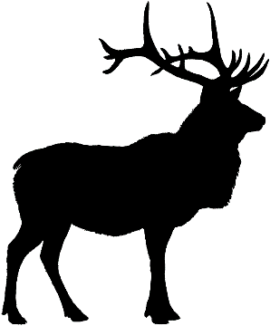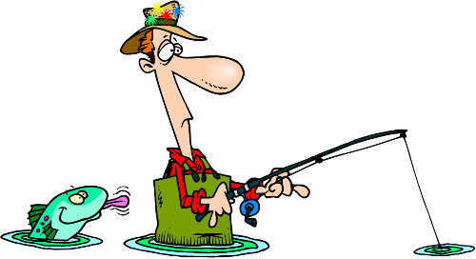[](http://www.google.com/url?sa=i&rct=j&q=&esrc=s&frm=1&source=images&cd=&cad=rja&uact=8&ved=0CAcQjRw&url=http://www.stormlake.org/index.aspx?NID%3D484&ei=tX_CVICpJMPaoATu8IDIAw&bvm=bv.84349003,d.cGU&psig=AFQjCNGGaSMf9Ei3IkqJfLW2m8YhDOSAgw&ust=1422119190268642)[](http://www.google.com/imgres?imgurl=http://www.prosportstickers.com/product_images/u/animal_tracks_vinyl_decals_2__46516.jpg&imgrefurl=http://www.prosportstickers.com/products/Animal-Tracks-Vinyl-Decals-2.html&h=224&w=300&tbnid=C6dDoLPJQw65wM:&zoom=1&docid=pbXTiUJl7iHbeM&ei=EoDCVNDgO4LToATMuILQCA&tbm=isch&ved=0CFcQMygwMDA)

WILDLIFE BIOLOGY  
 Get Wild and Earn   
 Science Credit

Fly-Fishing Trip Wildlife Management  
 Tackle Crafting Wildlife Identification   
 Hunter Safety Survival